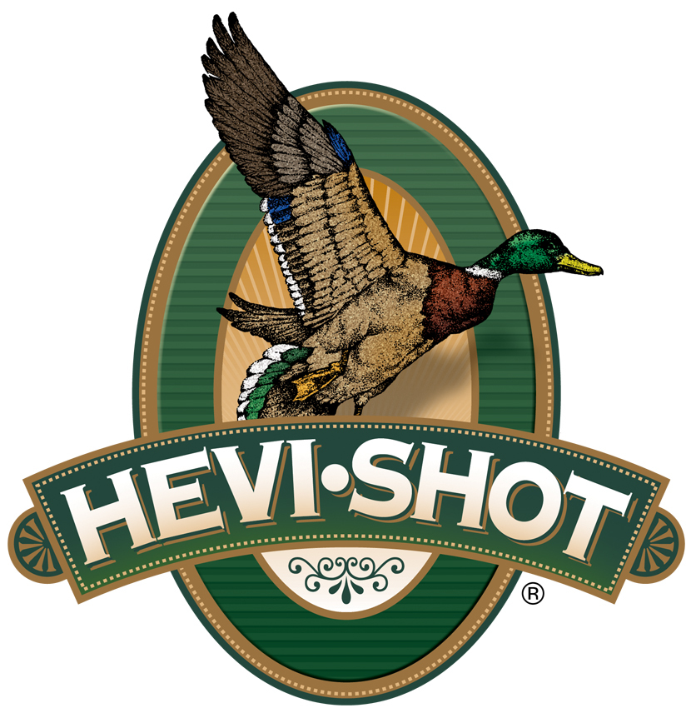

FOR IMMEDIATE RELEASE
HEVI-Shot’s New HEVI-Steel Upland Loads Now Shipping
SWEET HOME, Oregon – September 26, 2025 – HEVI-Shot is now shipping new 12- and 20-gauge loads in its HEVI-Steel Upland shotshell line. The latest additions include 3 and 5 shot in 12-gauge, and 6 and 7 shot in 20-gauge, all in 25-count boxes. These new upland hunting loads are currently being delivered to dealers nationwide.
HEVI-Steel Upland
“This new HEVI-Hammer 12-gauge load gives hunters more options to match their ammo with their hunt,” said Scott Turner, HEVI-Shot’s Product Line Manager. “By layering cast HEVI-Bismuth pellets over precision steel, we sharpen pattern consistency and increase terminal energy, which produces powerful, sledgehammer-like hits.”
HEVI-Steel Upland loads feature 7.8 g/cc precision steel pellets, HEVI-Shot’s best-in-class wad technology, and increased velocity to boost performance on fast, high-flying birds. Designed for dependable ignition and reliable cycling, these loads offer serious upland hunters a steel alternative that delivers excellent performance.
Part No. / Description / MSRP
HS61233 / HEVI-Steel Upland, 12 Ga, 2¾-in, No. 3, 1 1/8 ounce, 25-count box / $28.99
HS61225 / HEVI-Steel Upland, 12 Ga, 2¾-in, No. 5, 1 1/8 ounce, 25-count box / $28.99
HS62026 / HEVI-Steel Upland, 20 Ga, 2¾-in, No. 6, 1 ounce, 25-count box / $19.99
HS62027 / HEVI-Steel Upland, 20 Ga, 2¾-in, No. 7, 1 ounce, 25-count box / $19.99
HEVI-Shot products are available at dealers nationwide and online. For more information on all HEVI-Shot products and to sign up for product news, alerts, and promotions, visit www.hevishot.com.

Press Release Contact:
JJ Reich
Senior Manager – Press Relations
E-mail: media@tkghunt.com

About HEVI-Shot
Established in 2000 and based out of Sweet Home, Oregon, HEVI-Shot is a brand of The Kinetic Group, owned by CSG, a globally diversified industrial group based in Prague (Czech Republic). HEVI-Shot is an industry leader in performance shotshell, providing the next generation of shotshell loads to hunters—with their large and impressive selection of hunting ammunition options. HEVI-Shot is synonymous with high performance projectiles. The company meticulously designs each product to outperform any ammunition competitor in its class. That is why HEVI-Shot is the ammunition choice for serious hunters who live by their slogan: “I DIDN’T COME THIS FAR TO MISS!”

